Case Study
NHS Greater Glasgow & Clyde

Queen Elizabeth University Hospital Chlorine Dioxide Dosing

Location

Glasgow
Duration

41 weeks
Value

£1m

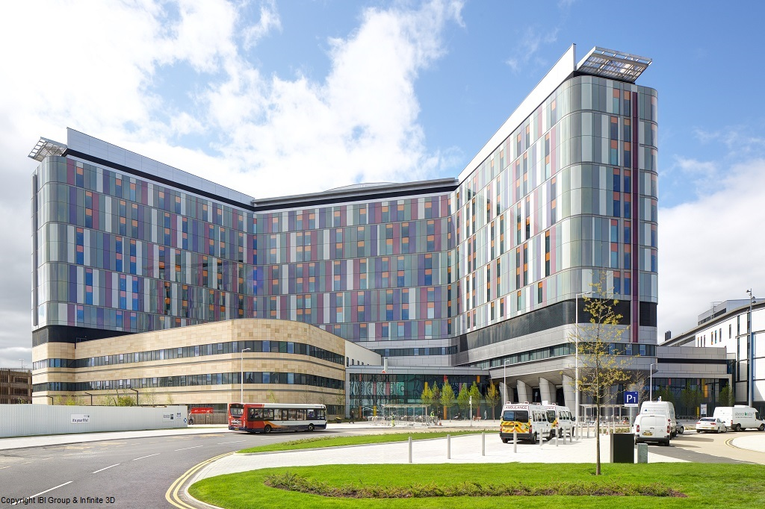

Design and installation of a chlorine dioxide treatment system to control waterborne pathogens within the hospital under the requirements of HTM04-01 and ACOP L8.
The latest in equipment monitoring capabilities were installed to provide a clear audit trail and show due diligence for public accountability.

To get treatment into the building water supply, in-tank dosing was used, with further chlorine dioxide dosing points installed on the hot water service return and cold water system for each heat station in plantrooms.

Each chlorine dosing location was designed to deliver and monitor chlorine dioxide dosing levels via a BMS interface. Each location has remote telemetry with the ability to produce a weekly report detailing chlorine dioxide and chlorite levels.

Pipework modifications were carried out and a water meter added to the filtration. New expansions vessels were phased in with the dosing system.

The chlorine dioxide generators and chemical storage are protected by chlorine dioxide gas alarms linked to the BMS and telemetry and activated plant auto shut off function.

Training was provided to board designated employees responsible for the day to day management of the systems. The installation met all statutory and regulatory requirements.

livingstonme.co.uk HEALTH & SAFETY QUALITY ENVIRONMENT

